SERVER MIGRATION TO CLOUD

Done by

TEAM - 09

LIKITHA ANUSHA 20A91A04K0

GEETHA BHAVANI 20A91A04K5

LAKSHMI ANUSHA 20A91A04K9

MADHAVI MANOHARI 20A91A2715

SOFIYA 20A91A04M4

**SERVER MIGRATION TO CLOUD**

**INTRODUCTION:**

Server migration to the cloud involves moving your server infrastructure from an on-premises location to a cloud-based environment. The cloud environment is essentially a collection of servers that are hosted by a third-party provider, and are accessed through the internet.

The benefits of migrating your server infrastructure to the cloud include increased scalability, flexibility, and cost savings. By moving to the cloud, you can quickly and easily scale up or down your server resources to meet changing demands. Additionally, you only pay for the resources you use, making it a more cost-effective solution than maintaining your own physical servers.

There are several steps involved in migrating your servers to the cloud. First, you will need to choose a cloud provider and select the appropriate cloud services for your needs. You will also need to plan your migration strategy, which may involve moving all of your servers at once or gradually migrating them over time.

Once you have a migration plan in place, you will need to prepare your servers for the move by backing up data and ensuring that your applications are compatible with the cloud environment. Then, you can begin the actual migration process, which typically involves copying your data and applications to the cloud environment and configuring the new server infrastructure.

Throughout the migration process, it is important to test and monitor applications to endure that they are functioning correctly in the cloud environment. Once the migration is complete, you can decommission your on-premises servers and begin using your new cloud-based infrastructure.

**SCOPE OF THE PROJECT:**

Server migration to the cloud can have a significant impact on an organization's IT infrastructure and operations. The scope of a server migration to the cloud depends on the size of the organization, the complexity of its applications and systems, and the specific goals of the migration.

Some factors that may influence the scope of a server migration to the cloud include:

**Number of servers:** The more servers an organization has, the more complex the migration will be. A larger number of servers may require a phased migration or a hybrid approach, where some servers are migrated to the cloud while others remain on-premises.

**Application complexity:** Applications with complex dependencies, configurations, and integrations may require additional planning and testing before they can be migrated to the cloud.

**Data migration:** Migrating data to the cloud can be a complex process, especially if the organization has a large amount of data or if the data is sensitive or regulated.

**Network infrastructure:** The migration to the cloud may require changes to the organization's network infrastructure, such as the configuration of firewalls and load balancers.

**Compliance requirements:** Organizations that operate in regulated industries, such as healthcare or finance, may have specific compliance requirements that must be addressed during the migration process.

In general, the scope of a server migration to the cloud will involve planning, testing, and executing the migration in a way that minimizes disruption to the organization's operations. The scope may also include ongoing monitoring and management of the cloud infrastructure to ensure optimal performance, security, and cost-effectiveness.

**PURPOSE FOR THE PROJECT:**

Server migration to the cloud involves moving applications, data, and other critical IT infrastructure from physical servers to a cloud-based infrastructure. The purpose of server migration to the cloud can be different for different organizations, but some of the key reasons why organizations choose to migrate their servers to the cloud are:

**Scalability:** Cloud servers can easily scale up or down depending on the changing needs of the business. This enables organizations to handle sudden spikes in traffic or workload without having to invest in additional physical hardware.

**Cost savings:** Moving to the cloud can help organizations reduce costs associated with managing and maintaining physical hardware. Cloud providers often charge on a pay-as-you-go basis, which can help organizations save money by only paying for the resources they use.

**Accessibility:** Cloud servers can be accessed from anywhere with an internet connection, enabling remote work and collaboration.

**Reliability:** Cloud providers typically have multiple data centres in different geographic locations, which can ensure high availability and redundancy. This can help organizations avoid downtime and ensure their applications and services are always available.

**Security:** Cloud providers often have robust security measures in place to protect against data breaches and other security threats. This can provide organizations with peace of mind knowing that their data is secure.

Overall, server migration to the cloud can help organizations improve their agility, reduce costs, increase accessibility, and improve the reliability and security of their IT infrastructure.

**Tools used:**

The used tools used in the project are:

1. VMware
2. AWS cloud

**1.VMware:**

VMware Tools is a suite of utilities that enhances the performance and functionality of virtual machines running on VMware hypervisors. It includes drivers and utilities that optimize the virtual machine's operating system, enabling features such as better graphics support, time synchronization, and improved network performance.

VMware Tools can be installed on a variety of guest operating systems, including Windows, Linux, and macOS. The installation process varies depending on the guest operating system, but typically involves mounting an ISO image containing the necessary files and running the installation wizard.

Once installed, VMware Tools provides a range of benefits to virtual machine administrators, including better resource management, improved guest operating system performance, and easier virtual machine management. It also enables features such as drag-and-drop file transfer between the host and guest operating systems, and the ability to share folders between them.

1. **AWS cloud:**

VMware Cloud on AWS is a service that enables organizations to run their VMware workloads on AWS infrastructure, providing the benefits of both cloud computing and on-premises infrastructure.

AWS provides a range of tools and services for managing cloud infrastructure, including Amazon EC2, Amazon EBS, and Amazon VPC. Amazon EC2 provides virtual machine instances that can be launched and managed in the cloud, while Amazon EBS provides persistent block storage for EC2 instances. Amazon VPC allows users to create a virtual network in the cloud, with full control over network topology, IP addressing, and security.

To bridge the gap between the two platforms, VMware and AWS have also collaborated to create tools such as VMware Cloud on AWS, which allows customers to run their VMware workloads on AWS infrastructure.

**TECHNOLOGIES USED:**

There are several technologies that can be used to migrate servers to the cloud. Some of the commonly used technologies are:

**Virtualization:** Virtualization technology allows you to create multiple virtual machines (VMs) on a single physical server. You can use this technology to create VMs on your on-premises servers and then migrate them to the cloud. This technology helps to reduce the number of physical servers required and makes migration to the cloud easier.

**Cloud migration tools:** There are several tools available that can help you to migrate your servers to the cloud. These tools automate the migration process and make it easier to move your servers to the cloud.

Overall, there are several technologies that can be used to migrate servers to the cloud. The choice of technology will depend on your specific requirements and the cloud platform you are using.

**PROOF OF CONCEPT:**

1. Create a virtual machine in VMware workstation.

2. Install an Ubuntu server image in the virtual machine created.

3. Install an Apache server in the Ubuntu image installed in the VMware.

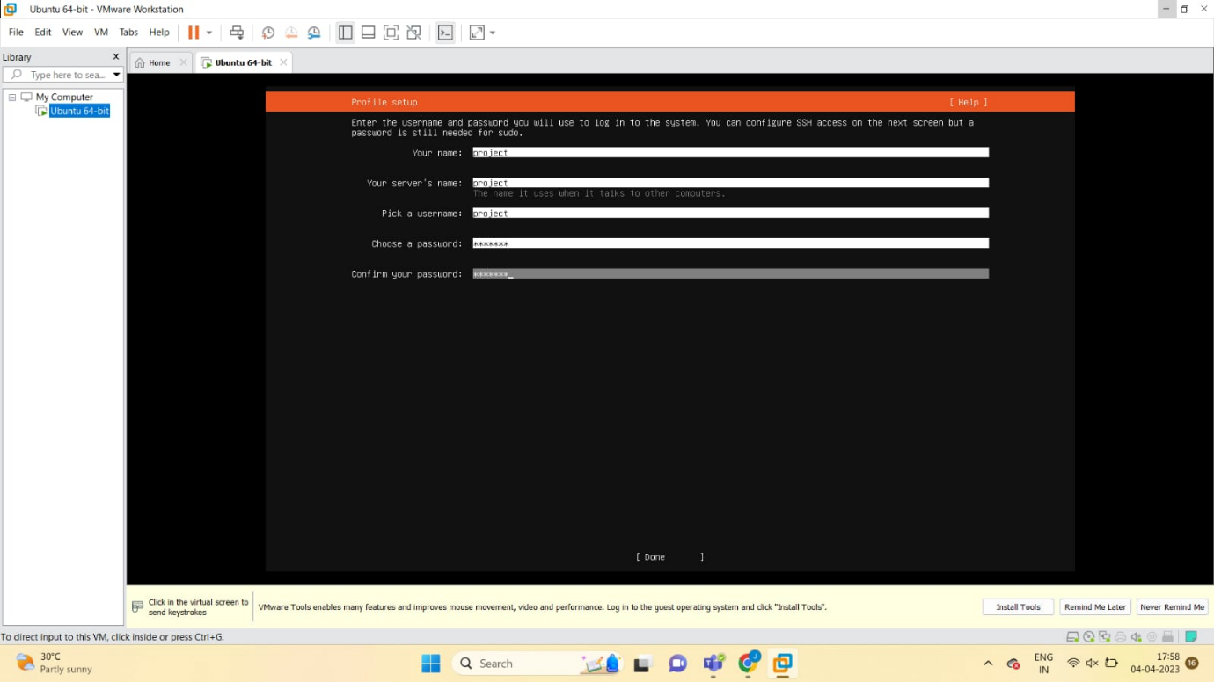

4. Install net tools to know the ip address by running the command “sudo apt install net-tools -y”.

5. Run the command “ifconfig” to know the ip address of the virtual machine.

6. Host the Apache server in a new tab by giving the ip address of the virtual machine.

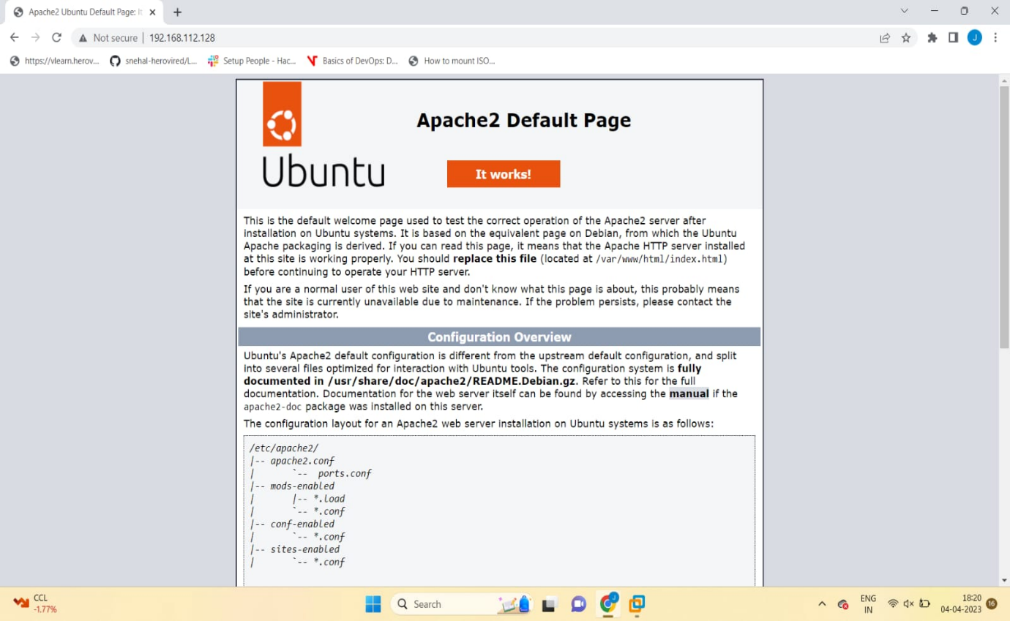

7. Install git by running the command “sudo apt install git”.

8. Now, download a web application and push the web application into GitHub repository.

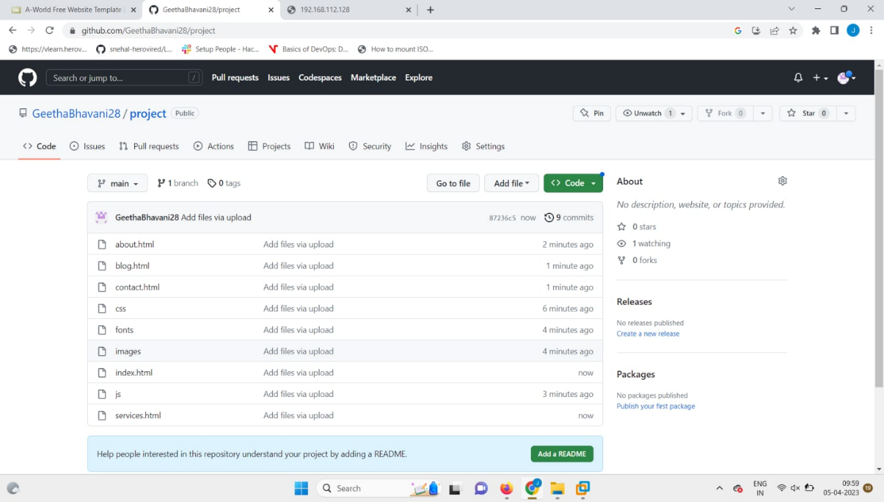

9. Then, clone the repository in which you pushed the web application in the virtual machine by running the command “git clone repository URL”.

10. Remove the ‘index.html’ present in the Apache server and replace the web application in the same directory.

11.Re-host the application by giving the ip address in new tab of google and we will notice that the same web application which you cloned from git.

# 

12. Power off the virtual machine and from the ‘File’ options, choose export to ovf (Open Virtualization Format’).

13. Download and install an ovf to ova tool to convert ovf (Open Virtualization Format) to ova file (Open Virtual Appliance).

14. Now, login to AWS management console and open S3(Simple Storage Service). Create a bucket with unique name and upload the converted ova file into the bucket.

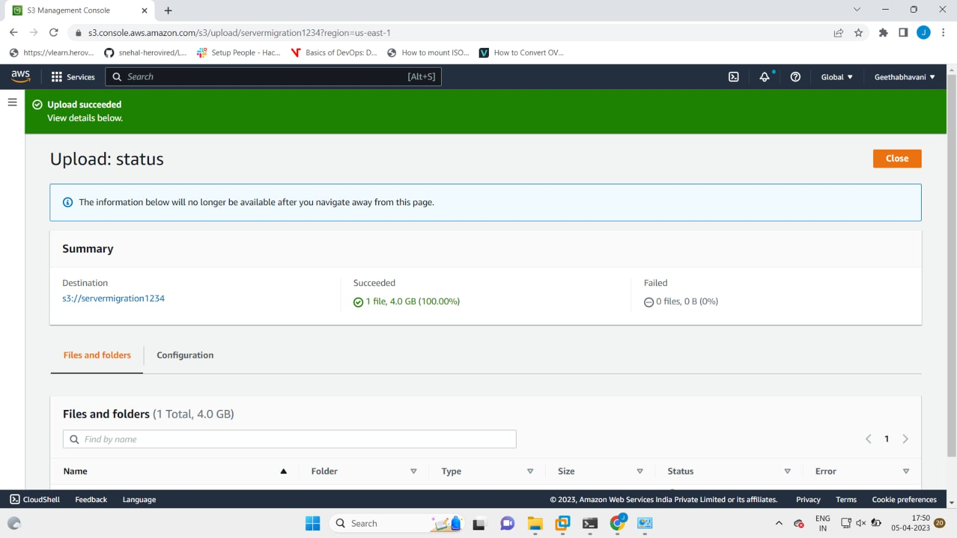

15. Edit ‘Block Public Access’ which are turned off by default so that no one can access the object and enable ‘ACLs’ which grant read and write permissions to the users.

16. Open Command prompt and run the following commands.

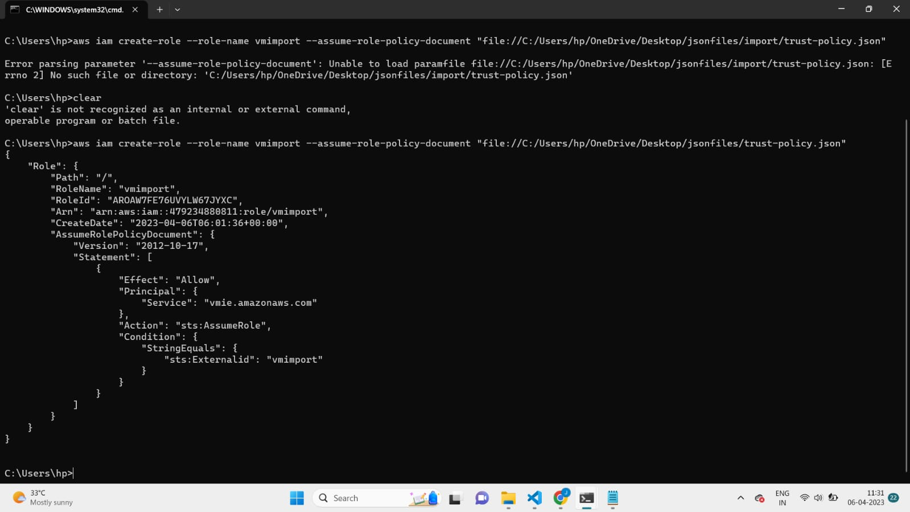

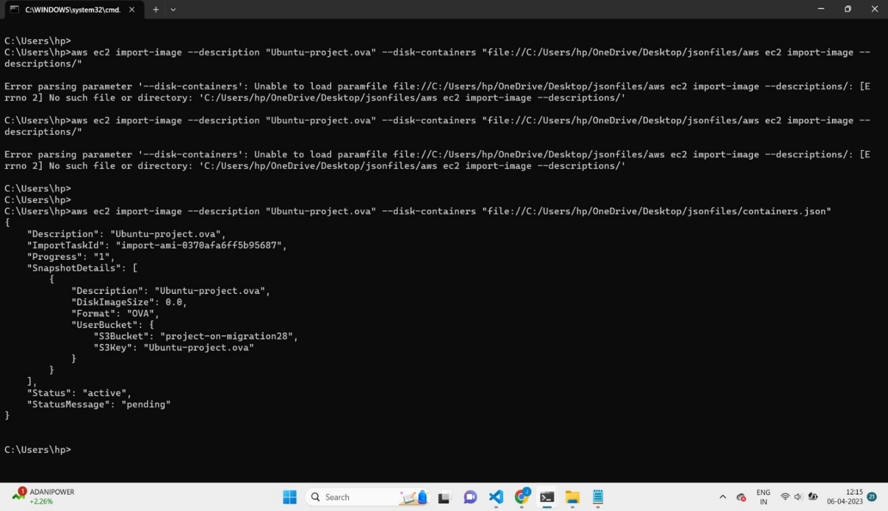

17. Now, sign in into the AWS iam console and create a user and role for the user.

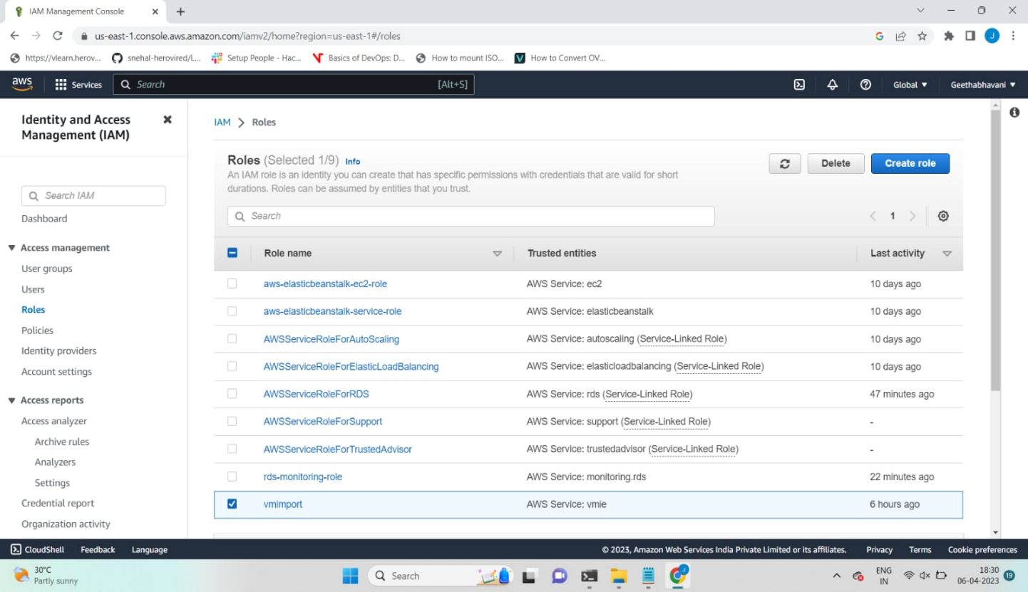

18. Now, go to EC2(Elastic Cloud Compute) page and from the ami’s, we will find an ami created.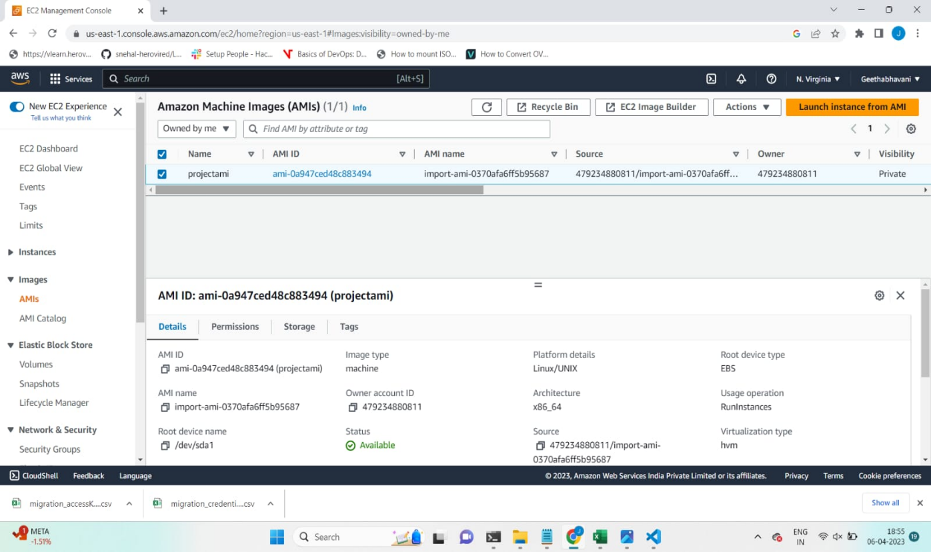

19. From the ami, launch an EC2 instance and check whether the instance is running successfully.

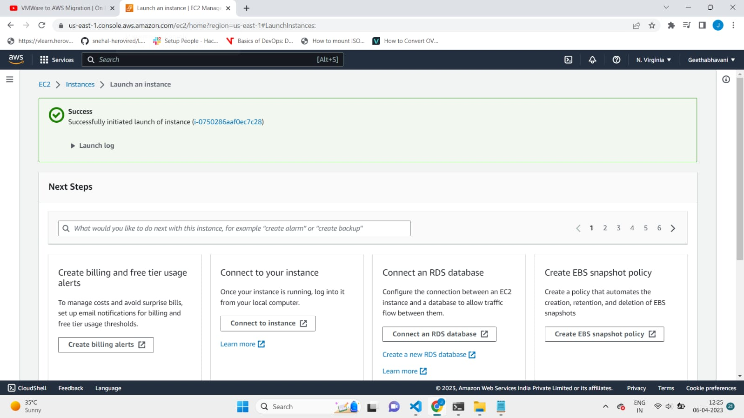

**REPOSITORY DETAILS:**

https://github.com/sofiya-4/innovators.git

**OUTCOME:**

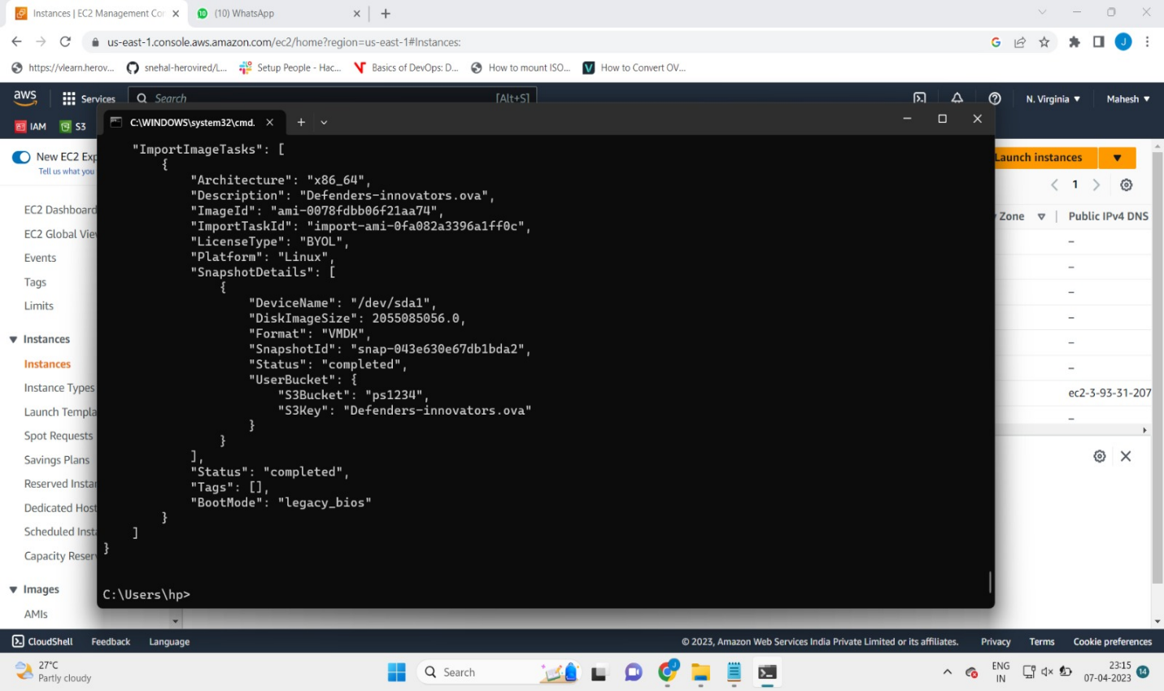

**CONCLUSION:**

Migrating servers to the cloud can offer a range of benefits, including increased flexibility, scalability, and cost-effectiveness. It can also simplify infrastructure management and improve business continuity and disaster recovery capabilities.

However, before deciding to migrate servers to the cloud, it is important to carefully evaluate the potential benefits and drawbacks for your specific organization. Consider factors such as data security and compliance requirements, application dependencies, and the potential impact on staff and operations.

Ultimately, a well-planned and executed server migration to the cloud can help organizations leverage the benefits of cloud computing while minimizing disruption and maximizing ROI.